Turbidity Sensor Manufacturing Tutorial

Rima Rebei (Spring 2019)

**Phase 1: Soldering**

What you will need:

* Sensor PCB
* LED PCB
* Wires (red, black, color)
* Wire strippers
* Tweezers

Electronics:

* TSL237T Sensor OPT 640NM Ambient 4SMD
* VSMY2850G Emitter IR 850NM 100MA SMD
* Surface mount Capacitor 0.1UF 250V X7R 0603
* Surface mount Resistor 200 OHM 0603

***=> Aim: create hardware and assemble electronics for Turbidity sensor***

1. **Sensor PCB**: Solder on sensor and capacitor on this board. Soldering on the sensor is a bit tricky but make sure all 4 pins are soldered on to the board and they are not touching. Make sure the notch on the part is lined up with the notch on the board (i.e. part is oriented in the right direction). Use tweezers to help with this process.

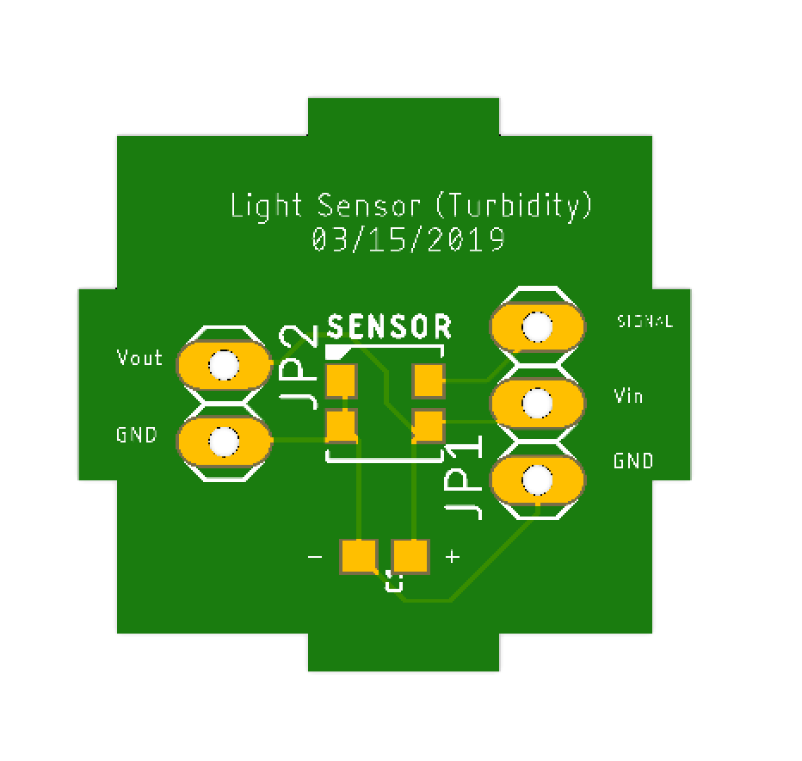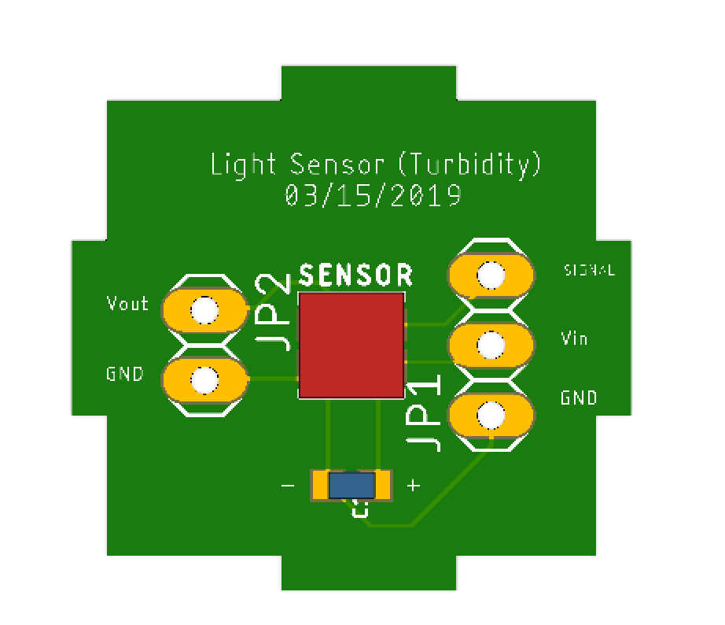

2. **LED PCB**: Solder on LED and resistor on this board. The LED is much easier to attach then the sensor, however finding the cathode and the anode of the LED is a bit tricky. Put the LED in the light, on the side of the anode, the corner of the LED square will be chipped off.

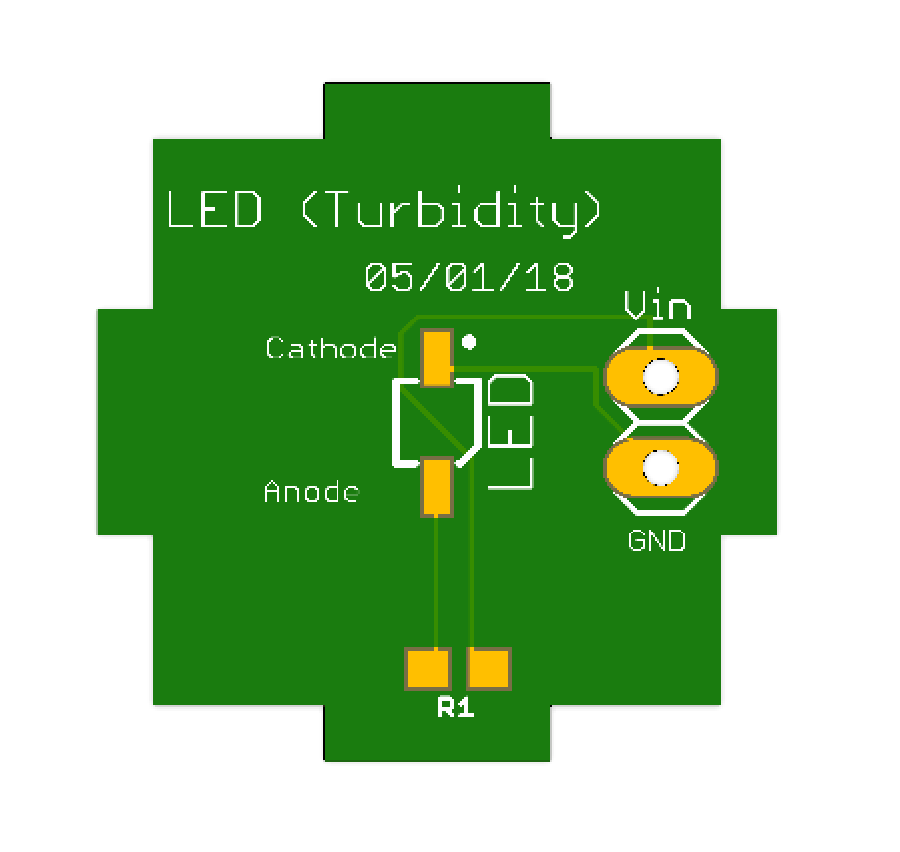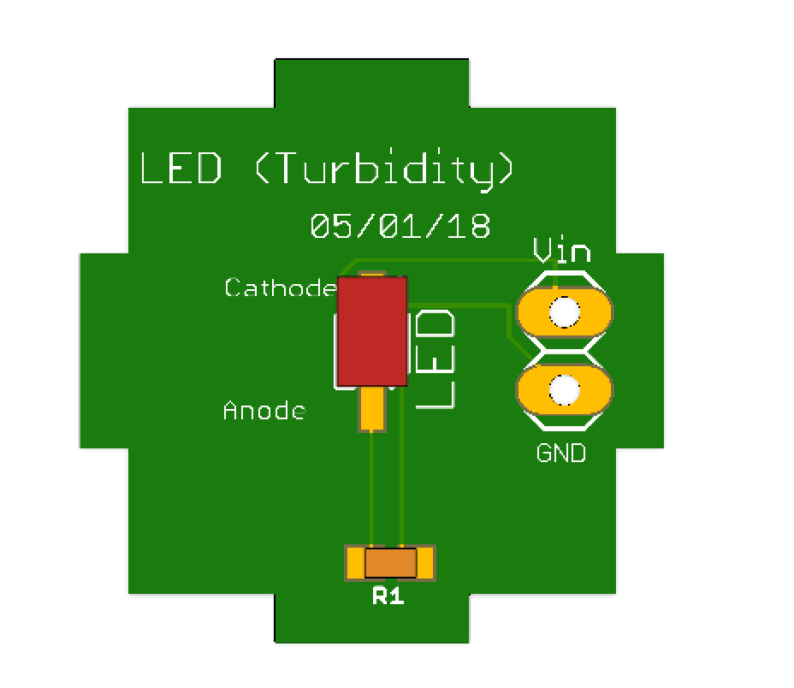

3. **Connecting Wires**: The Vin pin on the LED board will connect to the Vout Pin on the Sensor Board and the corresponding GND pins should also be connected with wires about 2 inches long. Make sure to attach the wires from bottom to top and solder on the top. Try to clip the wires down so they don’t stick up too much. Also make sure the solder height isn’t taller than the sensors on the boards. These wires also need to be long enough so they can fit in the mount as so:

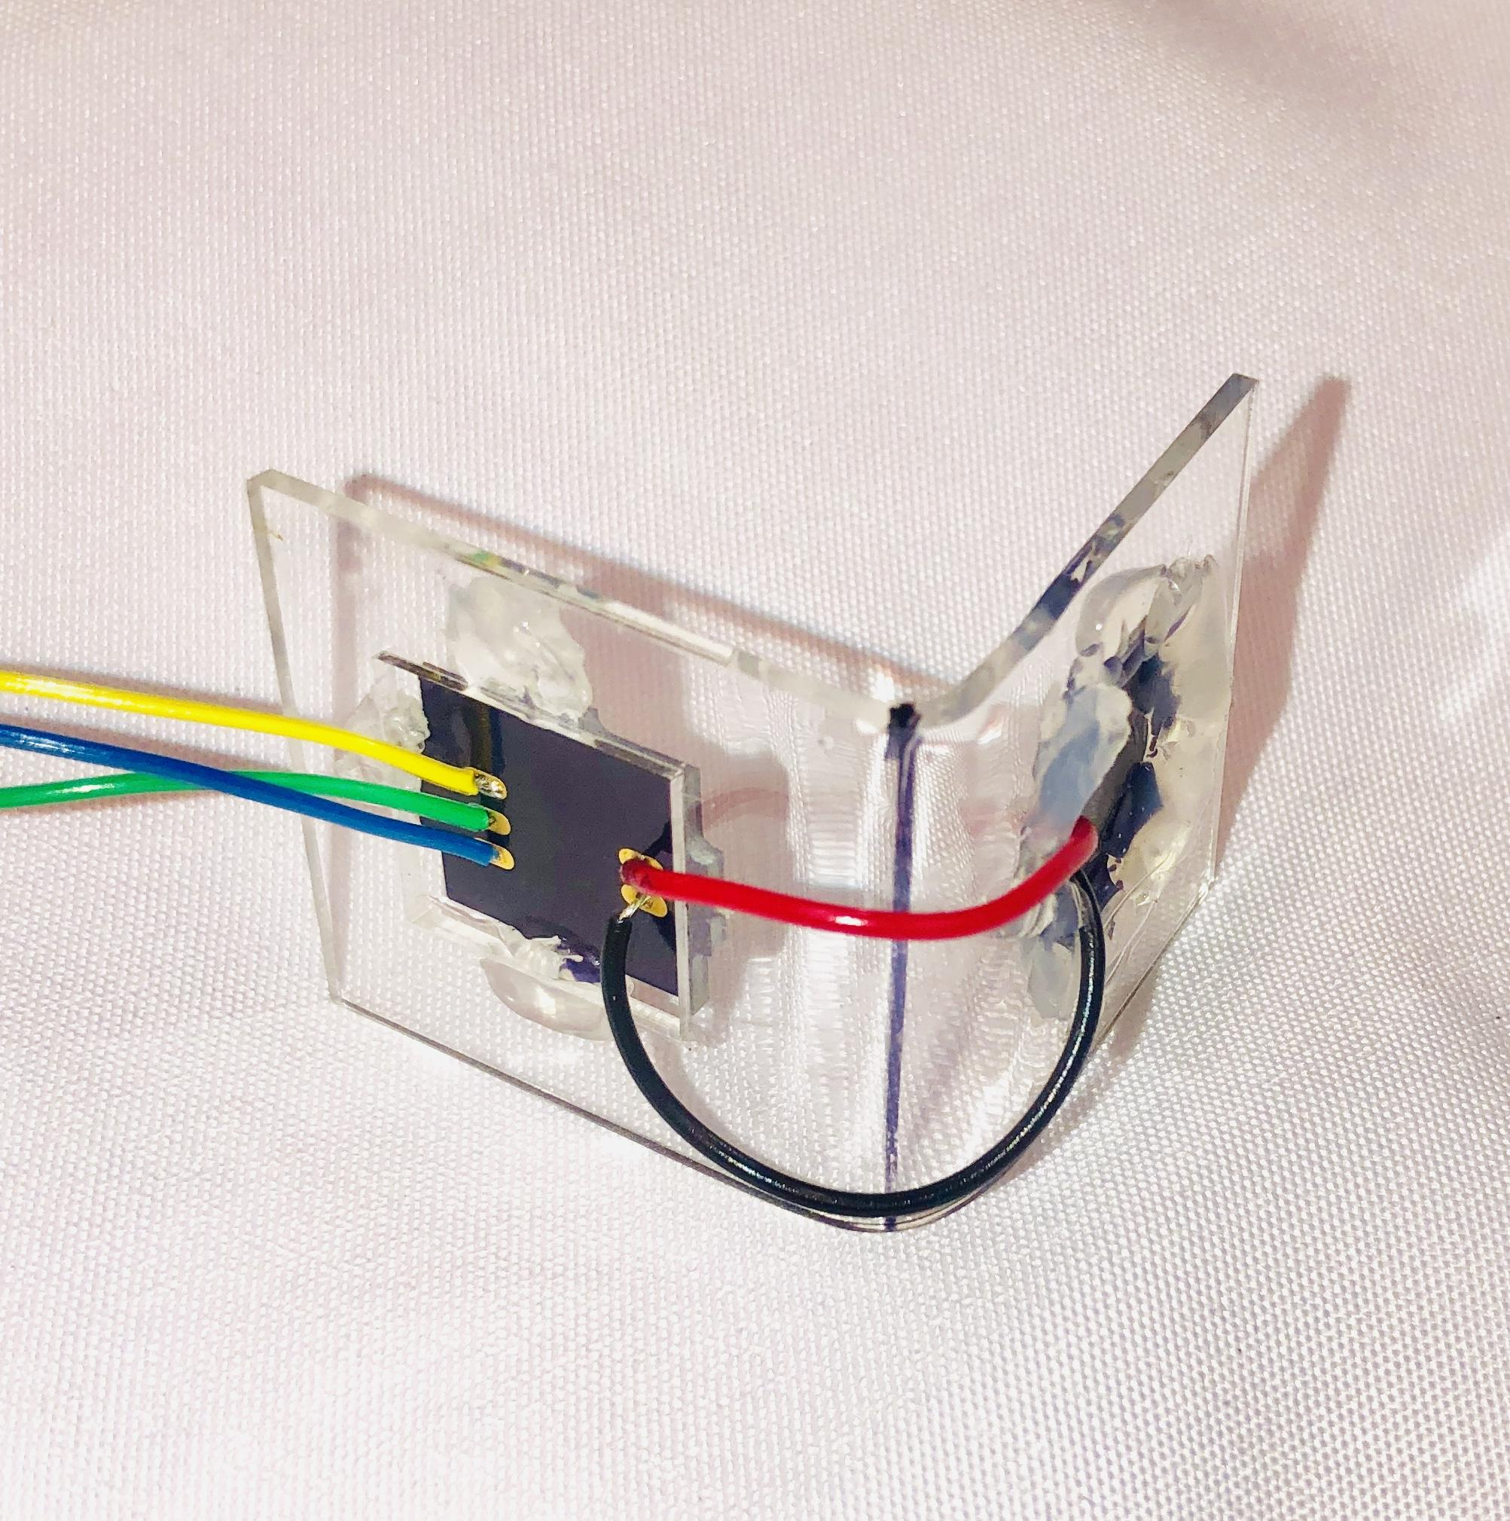

Then, on the sensor board, wires should be soldered on the Signal (colored wire), Vin (red), and GND (pins) which are located on the right side of the board. These wires should be at least 20 inches long. Use ribbon cable. Use a thicker strand than we did before and be careful not to pull out too much of the metals strands when stripping the wire or break the wire before epoxy. Again attach wires from bottom to top of the boards, solder on the top side, and make sure the solder isn’t too tall compared to the LED and sensor.

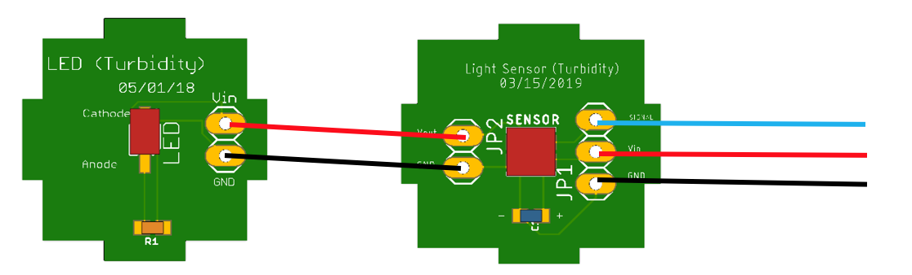

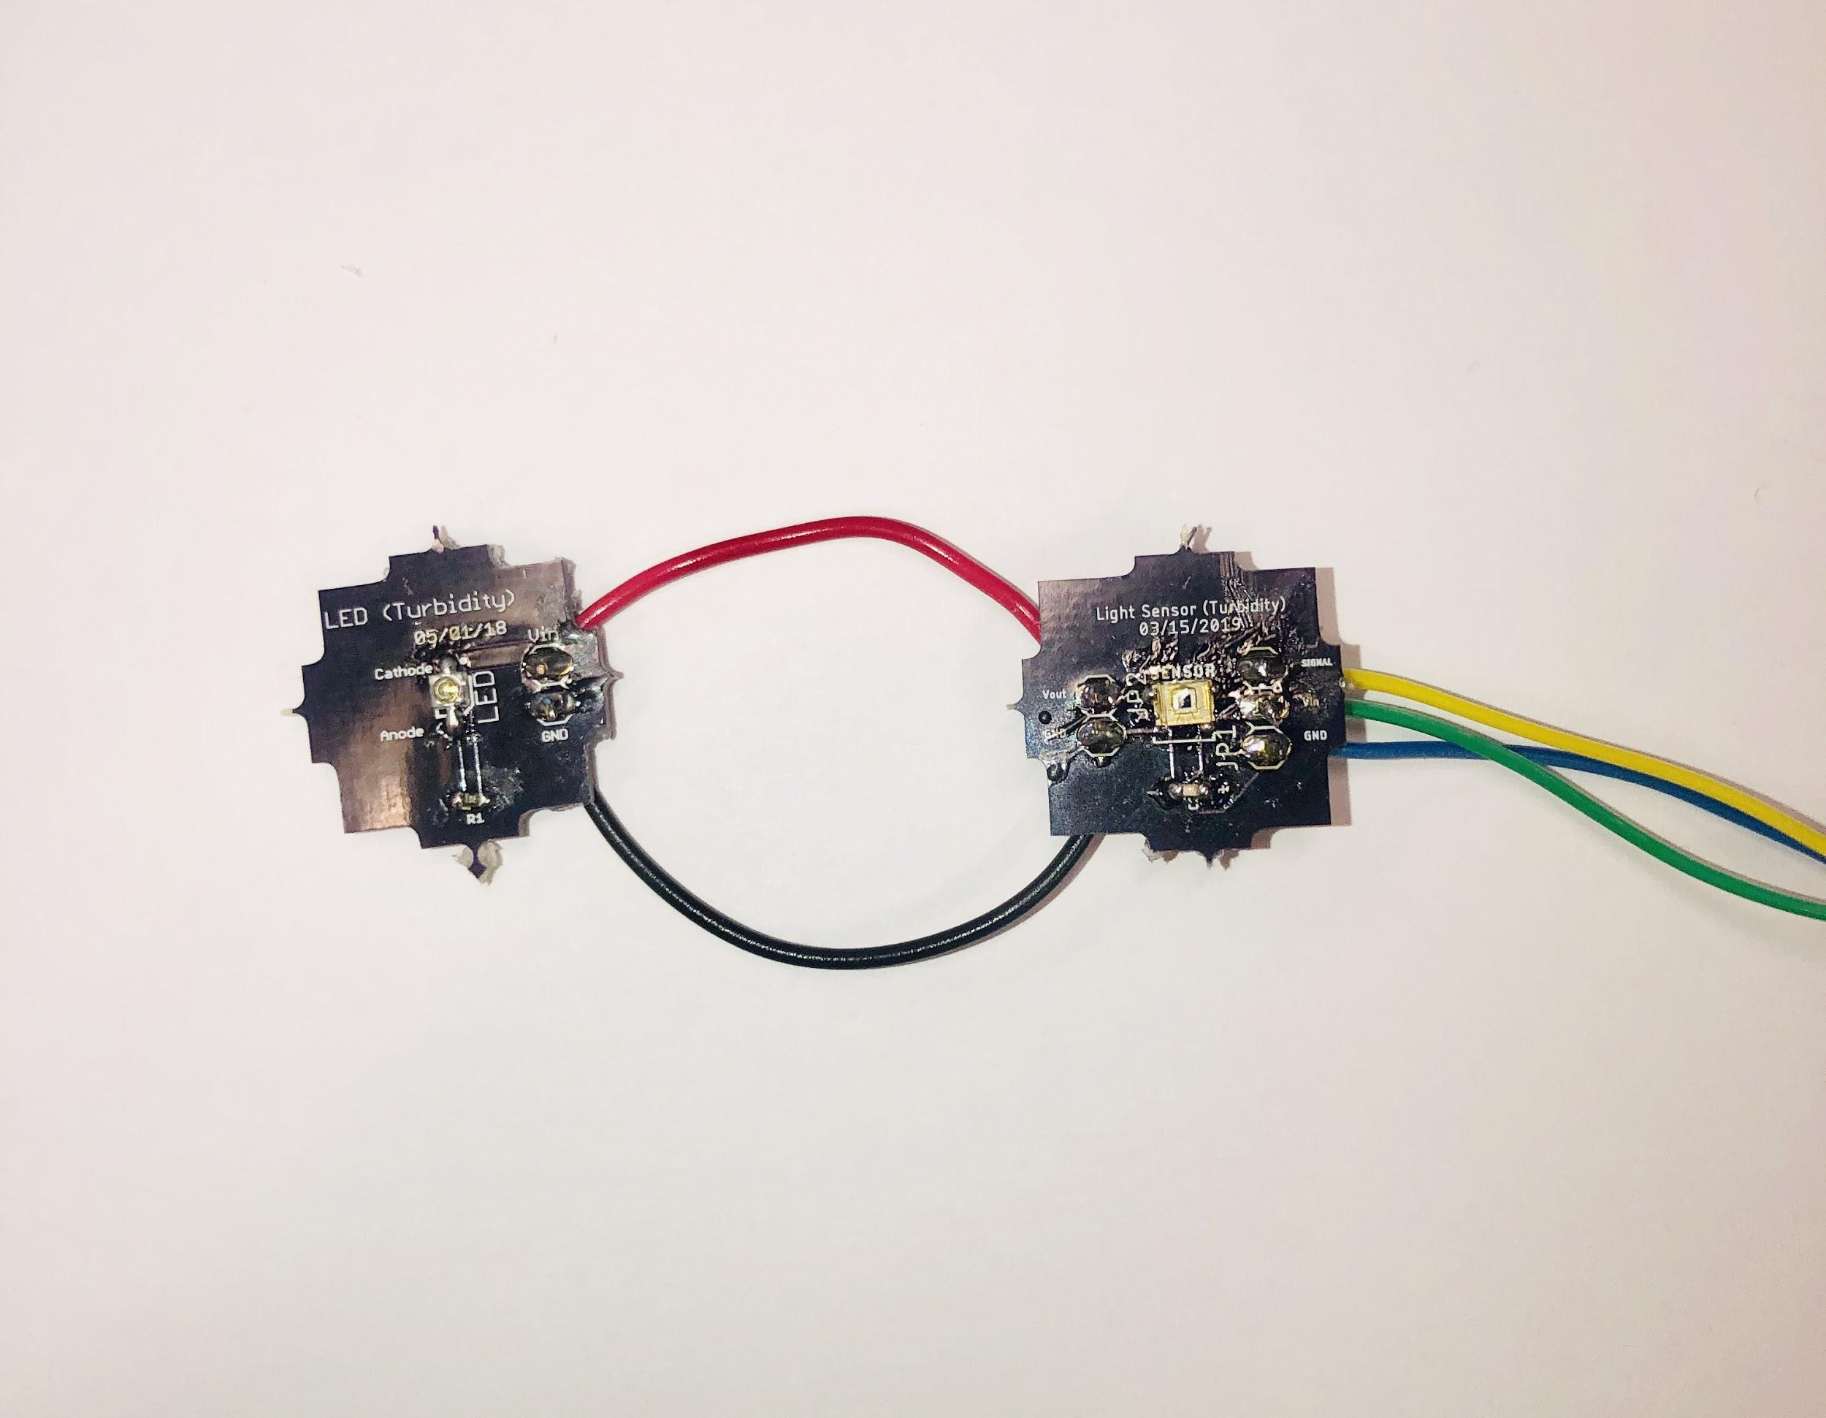

**Phase 2: Epoxy**

What you will need:

* Laser Cut Acrylic Parts
* Acrylic Glue
* Epoxy (part A and part B)
* Syringe
* Hot Glue
* Acrylic heater

***=> Aim: waterproof the turbidity sensor with epoxy.***

1. Hot Glue your PCB boards on the Laser Cut sensor base, with the acrylic squares on the red and black wire between the boards as shown. When looking at the front of the sensor base, make sure there are no gaps between the board and the acrylic. Make sure all the electronics are fully shown on the front side as well.  
   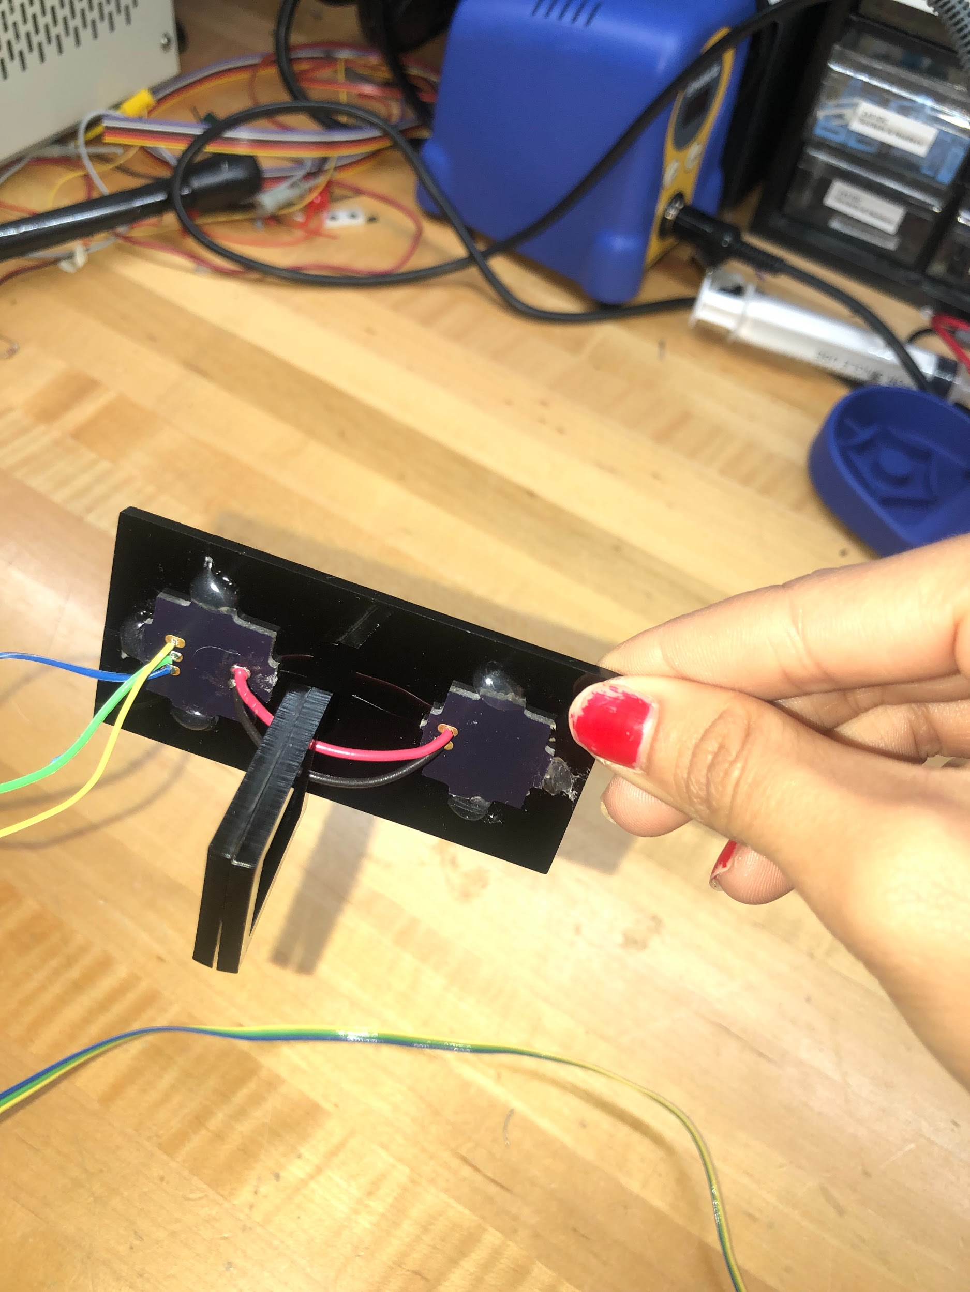 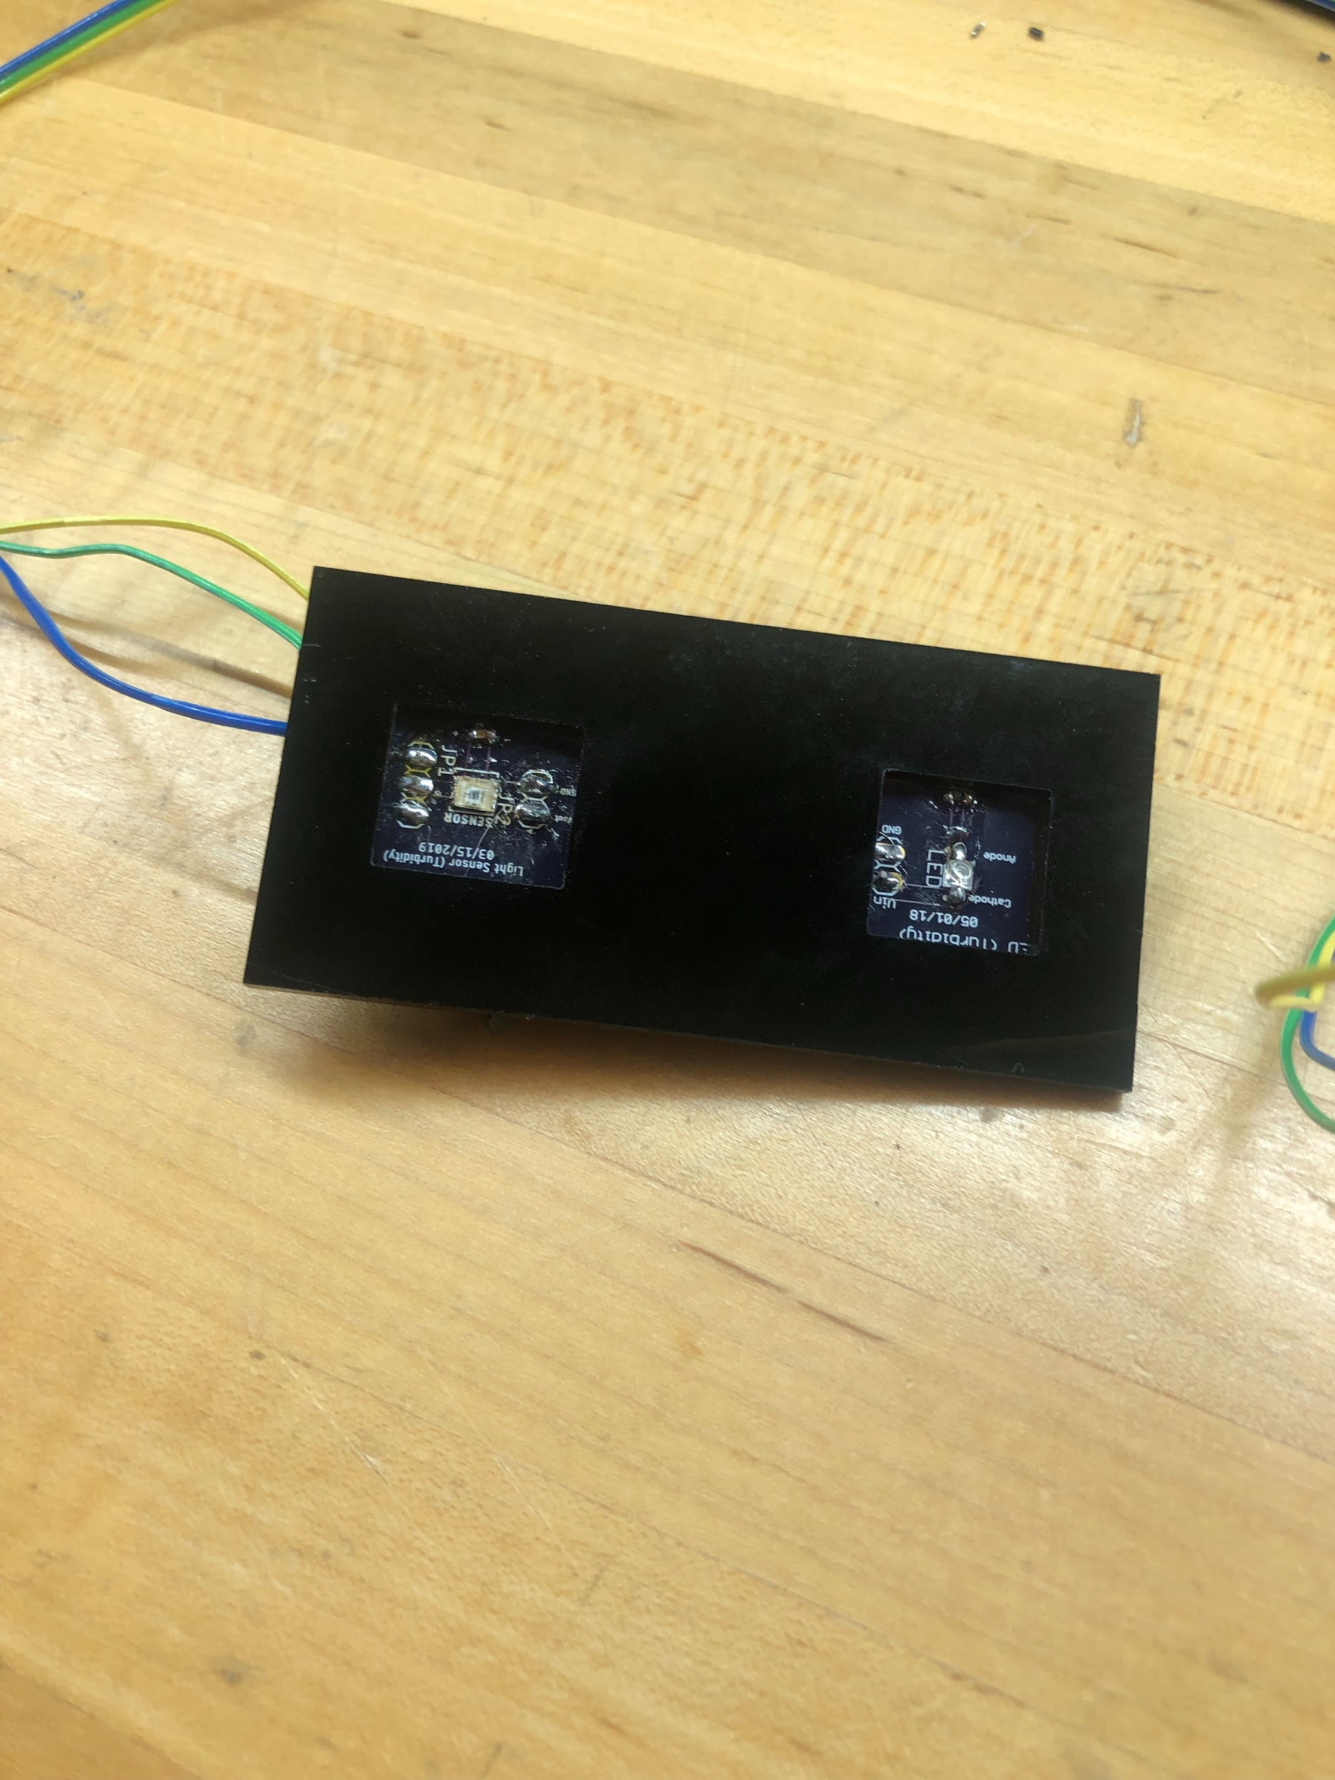
2. Now we are able to cover the front of the sensor with epoxy. Mix equal parts of part A and Part B of the epoxy and wait for 30 minutes. After 30 minutes, use a syringe to place the epoxy on the boards. Make sure you do NOT cover the sensor and LED on the boards as shown. Make sure all the solder is covered by epoxy. Use a support for the acrylic to make sure the epoxy is drying exactly level to the ground.

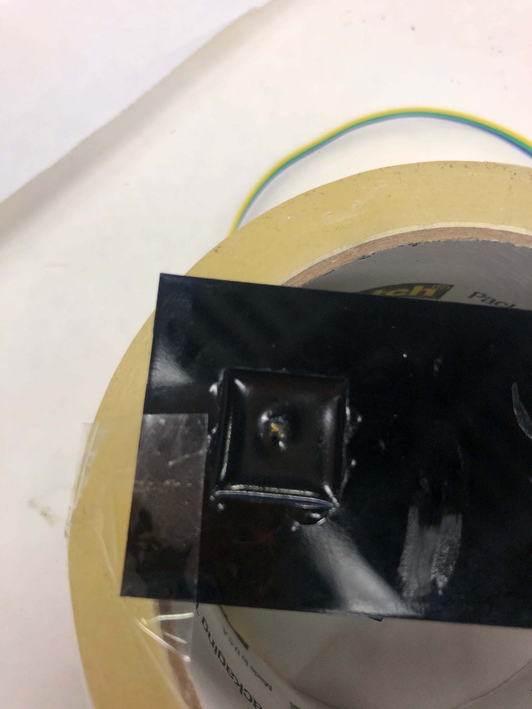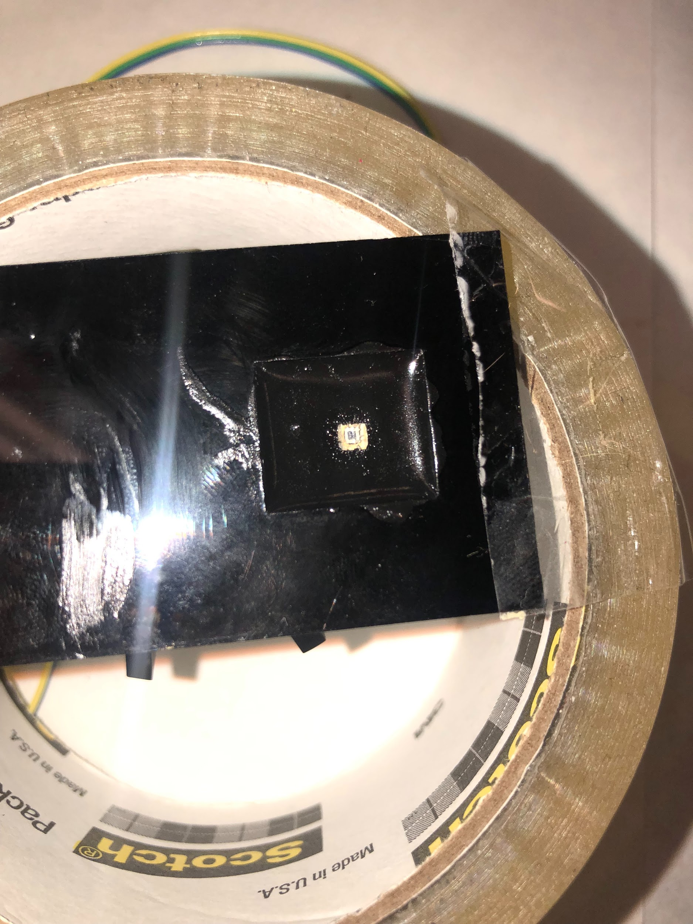

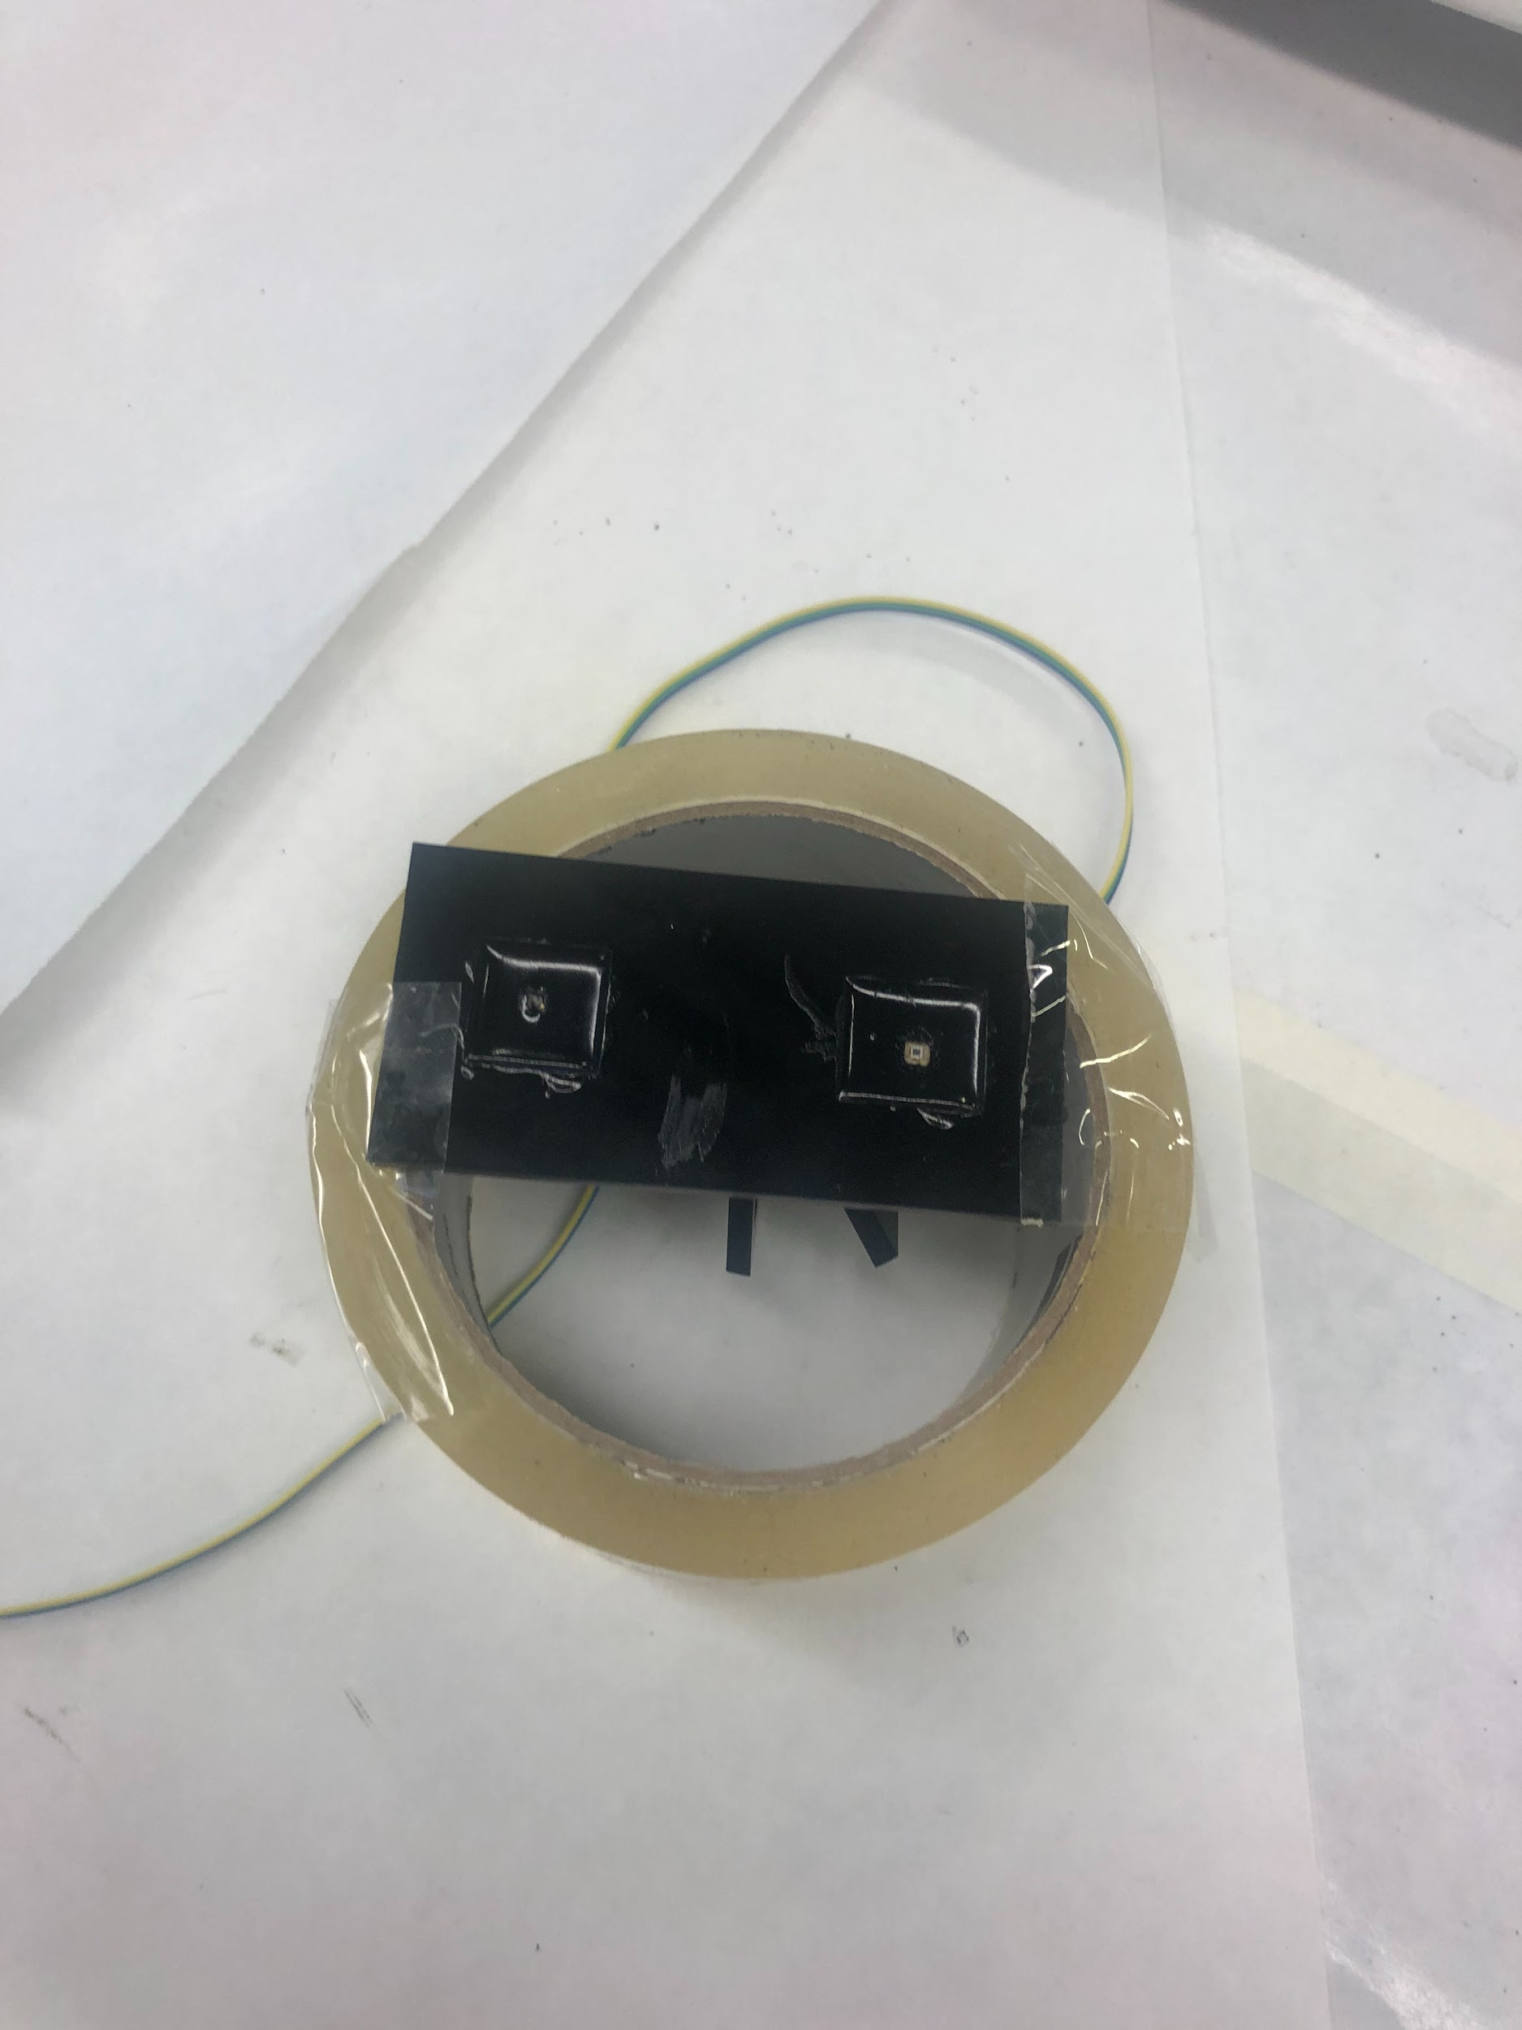

3. Wait 24 hours for the epoxy to dry. Once this is finished, you can peel off the hot glue you used to attached the PCB boards on the acrylic on the back side. Now, using the acrylic glue, glue the acrylic squares to the acrylic base and around the back of the PCB boards. After glueing, repeat the epoxy process on the back side. This side will be easier because you do not need to worry about not covering any electronics.

4. Once the epoxy is dried on both sides, it is time to bend the acrylic. Measure out the center on the board.

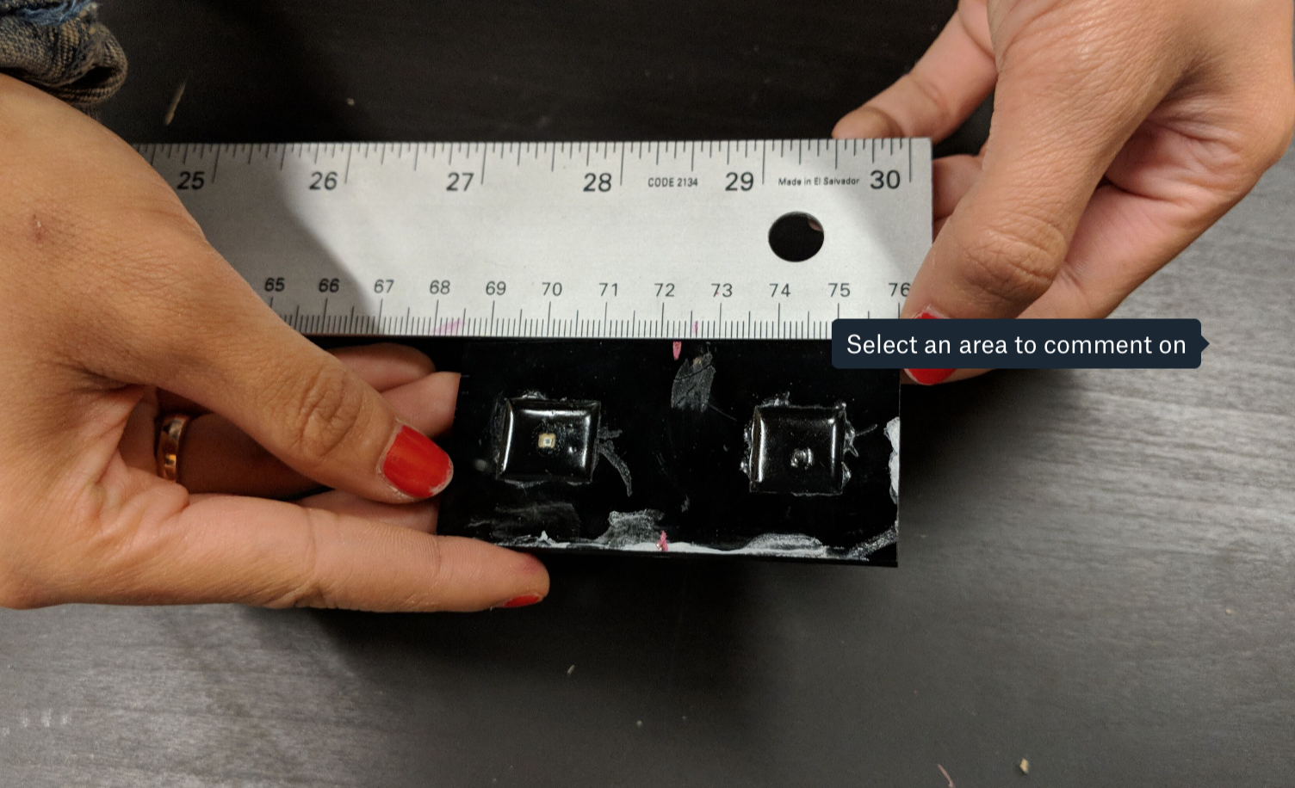

5. Then place the acrylic center on the heater like shown. Make sure the side with the wires is facing upwards. Do not get the wires too hot or they will melt.

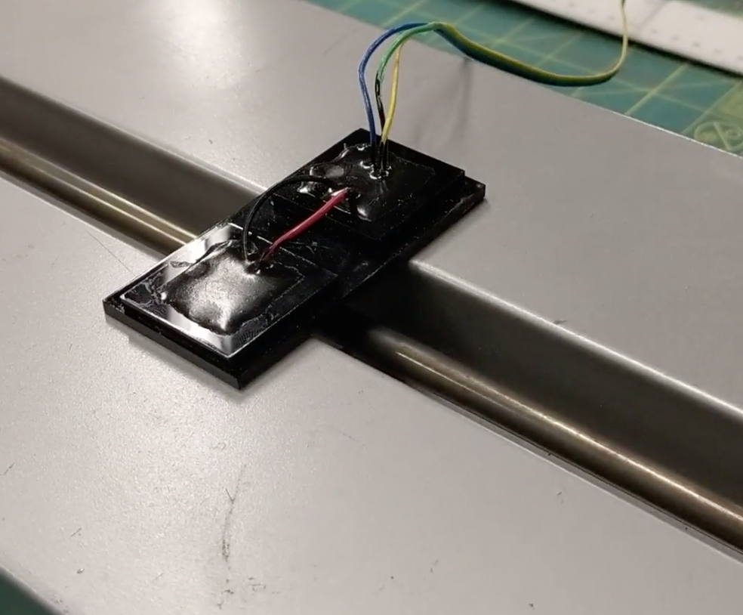

6. Once the acrylic is heated enough (~3 min), press it up against a wall to create a 90 degree angle and hold until the acrylic is completely cooled (~1 min).

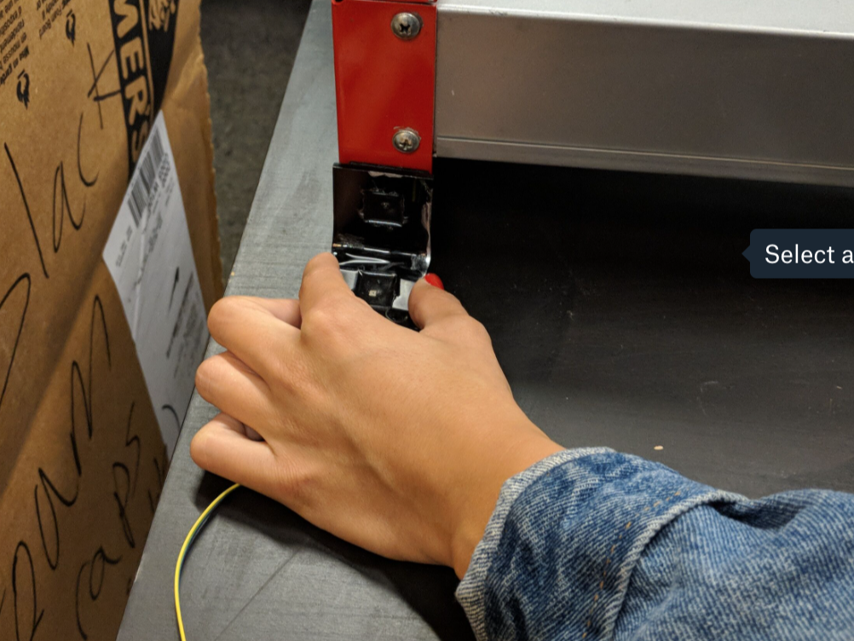

**Phase 3: Connecter**

What you will need:

* Solder
* Connecter (for 3 Wires)
* Tweezers
* Wire cutters

***=> Aim: allow the turbidity sensor to be connected to the Feather board.***

1. Trim the stripped part of the long wires so they are only the length of the connecter port (black part). Then using the tweezer, place each of the wires in one of the metal bases and solder the wires in. The order of the wires is important here. The order of the wires from left to right on the front side (as pictured) is as follows: digital pin output, Vin, and ground wires. Make sure the solder doesn’t stick out over the metal edge.

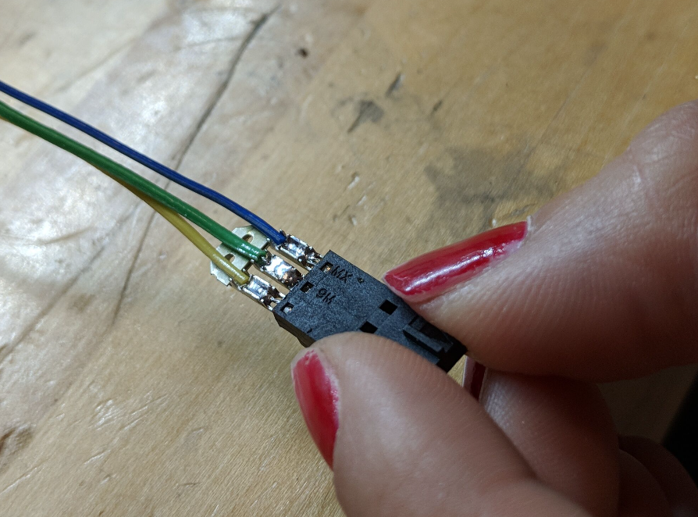

1. Once the wires are all soldered in, push the metal part into the black plastic case until it is all the way in the connector. Be careful that the wires do not break in this process!

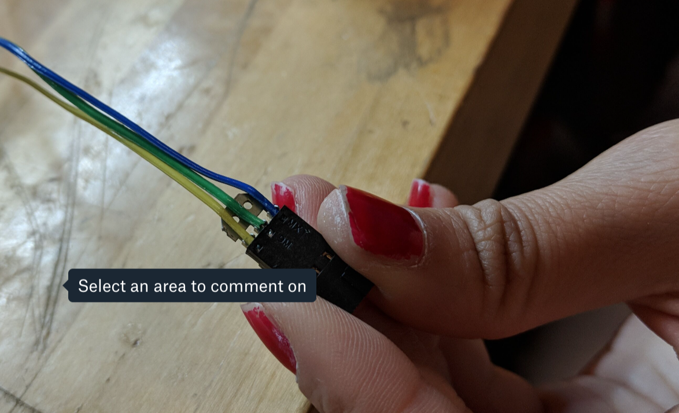

1. Fold away the metal edges hanging off. Now you have a working turbidity sensor to plug into the feather board!

